**NBTX10442_LAB -B WEEK-7**

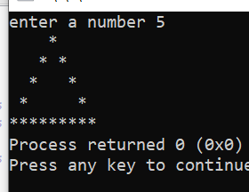Q1. #include<stdlib.h>

#include<stdio.h>

int main()

{int x;

printf("enter a number ");

scanf("%d",&x); //x is the number entered by the user

for(int i=x;i>1;i--) //i is the row number

{

for(int j=i;j>1;j--) //j is for space 1

{

printf(" ");

}

printf("*");

for(int a=x-i;a>0;a--)

printf(" "); //a is for space 2 i.e b/w the triangle

for(int a=x-i;a>1;a--)

printf(" ");

if(i!=x) // for print only 1 star at the top

printf("*");

printf("\n"); //for next line

}

for(int i=0;i<2*x-1;i++)

printf("*");

}

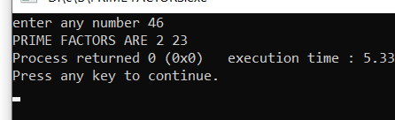Q2. #include<stdlib.h>

#include<stdio.h>

int main()

{int x,i,flag=0;

printf("enter any number ");

scanf("%d",&x);

printf("PRIME FACTORS ARE ");

for(int j=2;j<=x;j++)

{

if(x%j==0)

{

for (i = 2; i <= j/2; i++)

{ // condition for non-prime

if (j%i==0)

{

flag = 1;

break;

}

}

if (flag==0)

printf("%d ",j);

flag=0;

}

}

}

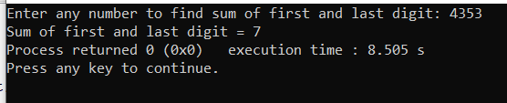

Q3. #include <stdio.h>

int main()

{

int num, sum=0, firstDigit, lastDigit;

printf("Enter any number to find sum of first and last digit: ");

scanf("%d", &num);

lastDigit = num % 10;

firstDigit = num;

/* Find the first digit by dividing num by 10 until first digit is left */

while(num >= 10)

{

num = num / 10;

}

firstDigit = num;

sum = firstDigit + lastDigit;

printf("Sum of first and last digit = %d", sum);

return 0;

}

Q4. #include<stdio.h>

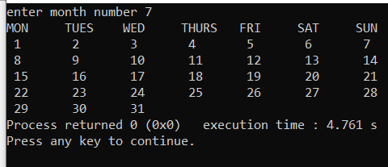#include<stdlib.h>

int main()

{

int month,a,b,days;

printf("enter month number ");

scanf("%d",&month);

if(month>0 && month<13)

{if(month==2)

{

days=28;

}

else if(month==1 || month==3 || month==5 || month==7 || month==8 || month==10 || month==12)

{

days=31;

}

else days=30;

printf("MON\tTUES\tWED \tTHURS \tFRI \tSAT \tSUN\n");

for(int i=1;i<=days;i++)

{

if(i%7==0)

printf(" %d \n",i);

else if(i%7==1)

printf(" %d \t",i);

else if(i%7==2)

printf(" %d \t",i);

else if(i%7==3)

printf(" %d \t",i);

else if(i%7==4)

printf(" %d \t",i);

else if(i%7==5)

printf(" %d \t",i);

else if(i%7==6)

printf(" %d \t",i);

}

}

}

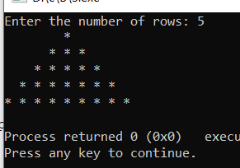Q5. #include <stdio.h>

int main()

{

int i, space, rows, k = 0;

printf("Enter the number of rows: ");

scanf("%d", &rows);

for (i = 1; i <= rows; ++i, k = 0) {

for (space = 1; space <= rows - i; ++space)

{

printf(" ");

}

while (k != 2 * i - 1) {

printf("* ");

++k;

}

printf("\n");

}

return 0;

}

Q6. #include <stdio.h>

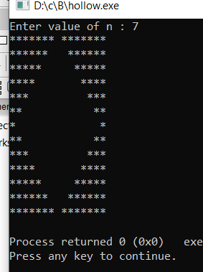

int main()

{

int i, j, n;

printf("Enter value of n : ");

scanf("%d", &n);

// Loop to print upper half of the pattern

for(i=1; i<=n; i++)

{

for(j=i; j<=n; j++)

{

printf("*");

}

for(j=0; j<=(2*i-2); j++)

{

printf(" ");

}

for(j=i; j<=n; j++)

{

printf("*");

}

printf("\n");

}

// Loop to print lower half of the pattern

for(i=1; i<n; i++)

{

for(j=0; j<=i; j++)

{

printf("*");

}

for(j=(2*i-2); j<(2*n-3); j++)

{

printf(" ");

}

for(j=0; j<=i; j++)

{

printf("*");

}

printf("\n");

}

return 0;

}